Renju lesson on October 11, 2001
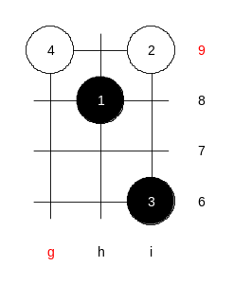
Hello everyone! Welcome to Online Renju Class. We will now begin. Today we will continue the study of i8 opening. So far, we have checked two choices of 4th move. Let us refresh our memory, which were those 4th moves? Yes, i10 and h7. You all have a very good memory. Today we will take a look at another 4th move. To make it more interesting for you, I let you vote to select the today’s 4th move. So many of you chose g9. I am surprised. :) Well, lets play it then.
Does anyone know the conclusion of this 4th move?
Well, there are three 5th moves (at least). Yes, j7, k8, j9.
Move 5-j7 is black easy win. Move 5-k8 is win too, but quite complicated. For example, the Click of Stone book does not show the correct variant of 5-k8 – no win there. Russian player Oleg Fedorkin has published the corrections to those variants. It is sure win there. The third alternative of 5th move is 5-j9 – black advantage, but no win. However, players who fear the complicated variants of 5-k8 often choose 5-j9 as it gives peaceful positional style.
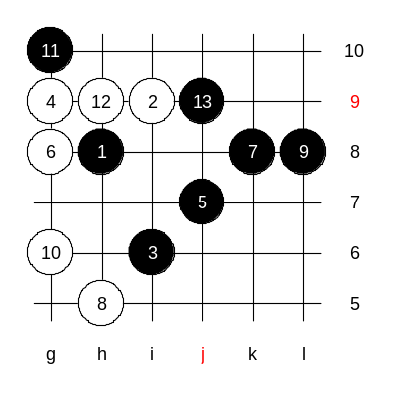
Well, do you have any questions about other 5th moves besides these three? Move 5-f9 has not been discussed in serious renju books. Moves 5-j8 and 5-g8 would need more study. Lets begin with the main 5th move and check the win there. There is only one interesting 6th move, others lose too fast. 6-g8. There are only two winning 7th moves – all other 7th moves probably lose! 7-h5 and 7-k8. It seems 7-k8 is the easiest win. 9-L8 – must!!! L8 and j8 are very different. For the simplicity, black can force the game with 11-g10.

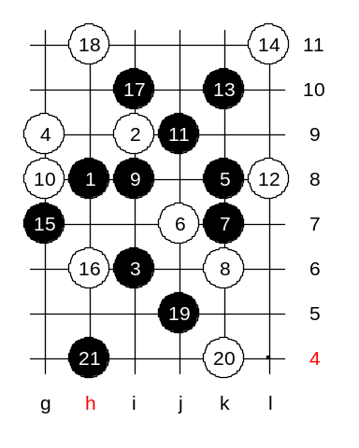
Another 5th move. Black win, but really hard. Move 6-j7 is forced. Any other 6th move that lets black take the j7 point loses fast. I guess many of you know the moves of this variant until 19…21. We will check the main variant first then we go deeper. 8-g8 is necessary. If 10th move is in the middle then 11-j9 wins fast. Now, black plays 11-j9 anyway. The first 15th moves on the board. This is the main variant. How many of you knew these 15 moves before? Nobody? Wow. In fact, this is one of the oldest variants of renju history. It is very complicated. For example, I do not think any of the A-final players remembers all the winning variants here. Including me. Therefore, I have couple of papers on my lap with Fedorkin analyses. I am going to show them to you. There are two 16th moves – h6 and g6. Let us check h6 first. The variant up to 21st move is traditional – no need to check anything. See the position on the board after the 21st move – very complicated.
White is taking key points here, just as black does.
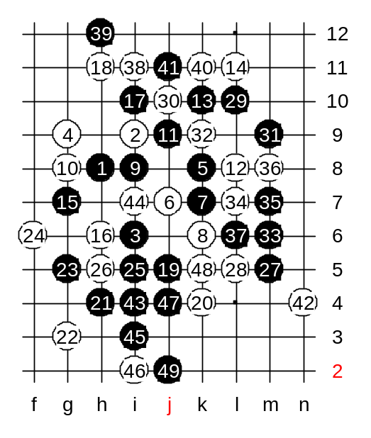
There are 27 stones on board – it is the crucial moment. Any inaccuracy from either side would lead to the failure. Interesting thing is – the black problems just began, but Click of Stone variant ends just here on 27th move. It is like leading people to a very complicated maze without telling people the way out. Fedorkin analyses discusses several 28th moves here. So many of you pointed out 28-L5. OK, lets begin with it. Most of the analyses begin with 29-L10, with the remark that later use of L10 may fail. Move 29-L10 is the right timing – not earlier, not later. 32-k9 or k11 – same win.
Imagine, all the variants are as complicated as this – not easy to remember them!

Next time we will continue our analysis in these variants.

